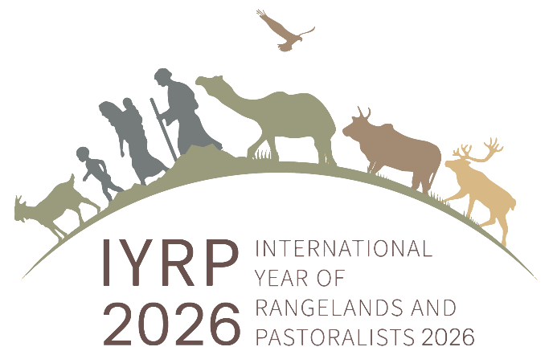
Media Messages for the IYRP 2026
April 2022

BACKGROUND/HISTORY OF THE EFFORT
The road towards the declaration of an International Year of Rangelands and Pastoralists (IYRP) by the United Nations has been long and rocky compared to the focus on other sectors such as forest or cropland sustainability. The idea was first discussed at the International Rangeland (IRC) and Grassland (IGC) Congress held in Hohhot, China in 2008. The creation of an International Support Group (ISG) in 2015 helped to provide a stronger rational and the integration of social dimensions. This has led to a growing partnership of national, regional, and international organizations. Numerous events were conducted at international meetings between 2015 and 2021 to solicit support for an IYRP. In 2018, UN Environment published a Gap Analysis of knowledge about rangelands and pastoralism that helped to further highlight the significant neglect of these issues in both academic and development circles. Under the leadership of the Government of Mongolia, the proposal for designation of an IYRP was officially presented in 2019 to the Committee on Agricultural Secretariat of FAO and following COAG’s approval the proposal went on to be considered and approved by the FAO Council and FAO Committee. At that time, it was sent forward to the U.N. General Assembly. On March 15, 2022, 102 countries formally co-sponsored the IYRP. To date, 300 organizations from around the world have also expressed concrete support for the effort.
WHY AN IYRP?
- To increase worldwide understanding of the importance of rangelands and pastoralists for food security and environmental services
- To mobilize people worldwide to address today’s challenges and to grasp new opportunities in rangelands management and pastoralism
- To boost efforts for creating new knowledge and sharing experiences and practices
- To inform decision-making at all levels, calling for enlightened policy to benefit current and future generations
SAMPLE ELEVATOR SPEECH
More than half of the world is comprised of rangelands. Yet, as the global human population becomes more modernized, people in urban centers are often disconnected from rangelands and their importance to food security, conservation, and environmental services. IYRP’s mission is to promote an understanding and appreciation of rangelands around the world and the people who use them.
KEY IYRP MESSAGES
- Rangelands are where humanity began
- Rangelands cover more than half (54%) of the world’s land surface (Rangelands Atlas) and include grasslands, shrublands, woodlands, savannahs, and deserts
- Rangelands are multiple use lands
- Rangelands are a climate solution and sequester carbon
- Rangelands are critical to the livelihoods of more than 500 million people around the world
- Pastoralists have been stewards of the land for millennia
- Pastoralism is one of the most efficient ways to turn sunlight into food in marginal lands
- Pastoralists include ranchers, nomads, graziers, shepherds, and even jackaroos!
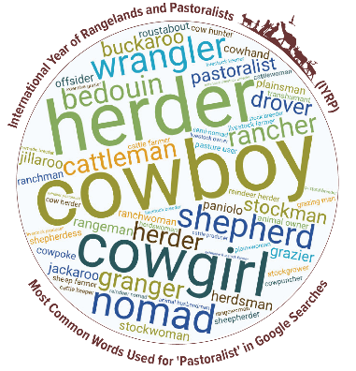
TWELVE THEMES (to be focused on through various types of educational programming during each month of the IYRP 2026)
- What are pastoralists? What are rangelands?
- Securing mobility and access
- Social and economic services
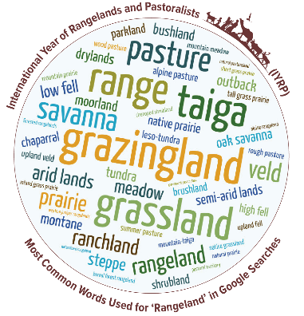
- Climate change and resilience
- Biodiversity and ecosystem services
- Soils, water, and land use
- Sustainable livestock consumption
- Indigenous knowledge and culture
- Sustainable livestock production
- Pastoralist women
- Pastoralist youth
- Sustainable technologies and innovation
LINKS FOR MORE INFORMATION
- Main IYRP website: https://iyrp.info/
- Introduction to the IYRP (Video) - https://youtu.be/zToSadWebwc?list=PLgz33fsrwiVkGSJE-I84wsKL8nOfRPdyU
- Pastoralism is the Future (Video) - https://youtu.be/DeqITzac9Ac
- Who are pastoralists? (Word Cloud) - https://iyrp.info/who-are-pastoralists
- What are rangelands? (Word Cloud) - https://iyrp.info/what-are-rangelands
- North American section: https://iyrp.info/north-america
- Facebook IYRP Global - https://www.facebook.com/IYRP2026
- Facebook IYRP North America - https://www.facebook.com/IYRPNorthAmerica2026/
- Twitter IYRP Global - https://twitter.com/IYRP2026
- Twitter IYRP North America - https://twitter.com/IYRPNA2026
- Instagram IYRP Global - https://www.instagram.com/iyrp2026/
- Instagram IYRP North America - https://www.instagram.com/iyrpnorthamerica2026/

